Code:
#include <stdio.h>

int main(){
int num;
char S[10000];

scanf("%d", &num);
scanf(" %[^\n]", S);

printf("%d \n%s", num * 2, S);

return 0;
}
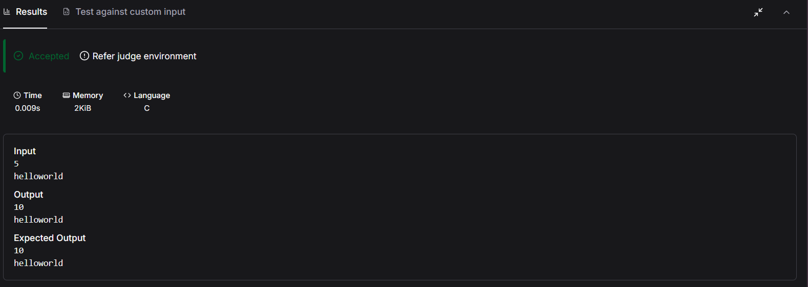

Link to code:
Read from STDIN, Write to STDOUT | Basics of Input/Output & Basic Programming Practice Problems

